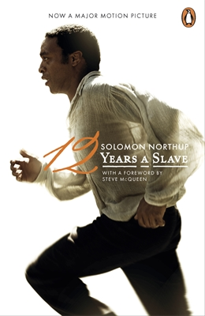Twelve Years a Slave

**Author: Solomon Northup**

**Format:** Paperback

**ISBN:** 9780141393827

**Size:** 129 x 198mm

**Pages:** 256

**Published:** 05 Dec 2013

**Publisher:** Penguin Classics

**Synopsis:**

**An official tie-in edition of this eloquent and powerful slave narrative, to accompany Steve McQueen's major new film starring Brad Pitt, Michael Fassbender, Benedict Cumberbatch, Paul Giamatti, Chiwetel Ejiofor and Quvenzhané Wallis.**

Perhaps the best written of all the slave narratives, *Twelve Years a Slave* is a harrowing memoir about one of the darkest periods in American history. It recounts how Solomon Northup, born a free man in New York, was lured to Washington, D.C., in 1841 with the promise of fast money, then drugged and beaten and sold into slavery. He spent the next twelve years of his life in captivity on a Louisiana cotton plantation.

After his rescue, Northup published this exceptionally vivid and detailed account of slave life. It became an immediate bestseller and today is recognized for its unusual insight and eloquence as one of the very few portraits of American slavery produced by someone as educated as Solomon Northup, or by someone with the dual perspective of having been both a free man and a slave.

A moving, vital testament to one of slavery's "many thousands gone" who retained his humanity in the bowels of degradation' - *Saturday Review.*

Solomon Northup was a free man kidnapped into slavery in Washington, D.C. in 1841. Shortly after his escape, he published his memoirs to great acclaim and brought legal action against his abductors, though they were never prosecuted. The details of his life thereafter are unknown, but he is believed to have died in Glen Falls, New York, around 1863.